Medical Care Collections Fund (MCCF) eBilling

Electronic Data Interchange (EDI)

Transactions Applications Suite (TAS)

Interface Control Document

ASC X12N/005010 278-217 Health Care Services Review

– Request for Review and Response

ASC X12N/005010 278-215 Health Care Services Review

– Inquiry and Response

Logo for the Department of Veterans Affairs, Office of Information and Technology, Product Development, including the official seal of the Department of Veterans Affairs


Department of Veterans Affairs

February 2018

Version 1.0

Revision History

|  |  |  |  |
| --- | --- | --- | --- |
| Date | Version | Description | Author |
| 2/20/18 | 0.0.1 | Initial creation of document | Steffen Maerdian - Halfaker |
| 2/28/18 | 0.9 | Finalization of draft | Steffen Maerdian - Halfaker |
| 3/5/18 | 1.0 | Draft review and update | Keith Oulson – Halfaker & Associates |
|  |  |  |  |
|  |  |  |  |
|  |  |  |  |
|  |  |  |  |
|  |  |  |  |
|  |  |  |  |
|  |  |  |  |
|  |  |  |  |
|  |  |  |  |
|  |  |  |  |
|  |  |  |  |
|  |  |  |  |
|  |  |  |  |
|  |  |  |  |
|  |  |  |  |
|  |  |  |  |
|  |  |  |  |
|  |  |  |  |

Table of Contents

1 Introduction 1

1.1 Purpose 1

1.2 Scope 1

1.3 System Identification 1

1.3.1 MCCF EDI TAS eBilling 1

1.3.2 FSC 2

1.4 Operational Agreement 2

2 Interface Definition 3

2.1 System Overview 3

2.1.1 Overview Diagram 4

2.2 Interface Overview 5

2.2.1 Connectivity between the systems 6

2.3 Operations 6

2.3.1 Data Extraction 6

2.3.2 Data Transformation 6

2.3.3 Sending/Receiving 7

2.4 Data Transfer 7

2.5 Transaction Types 7

2.6 Data Exchanges 7

2.6.1 FHIR Based Resources 7

2.6.2 JSON Format 10

2.6.3 Bundle Definition 10

2.7 Communications Methods 12

2.7.1 Ports and Protocols 12

2.7.2 ESB Configuration(s) 12

2.7.3 System Configuration 13

2.8 Performance Requirements 13

2.9 Security 13

2.9.1 Is within the VA firewall 13

2.10 Testing Requirements 13

2.10.1 Comparison of Data 13

2.10.2 Completeness 13

2.11 Policies and Constraints 13

2.11.1 HIPAA Compliance 13

3 Appendix A 14

3.1 Data Elements 14

3.2 Bundle 14

3.3 Resource Sections 1..N 15

3.3.1 278 Request FHIR Bundle Resources 15

3.3.2 278 Response FHIR Bundle Resources 51

3.3.3 Embedded following columns: 54

4 Appendix B - TASCore Mapping Rules 54

5 Appendix C – TASCore Default Values 54

6 Appendix D – FSC Mapping Rules 54

7 Appendix E – FSC Default Values 54

# Introduction

This document describes the interface between a MCCF EDI TAS application and the VA Financial Services Center in Austin, TX.

## Purpose

The purpose of this Interface Control Document (ICD) is to define the message structure and protocols which govern the interchange of data between eBilling within MCCF EDI TAS and the VA Financial Services Center (FSC) related to the electronic processing of

* ASC X12N/005010 278-217 Health Care Services Review – Request for Review and Response

and

* ASC X12N/005010 278-215 Health Care Services Review – Inquiry and Response

## Scope

This ICD specifies the interface between MCCF EDI TAS eBilling and FSC. This document provides details on the functional, performance, operational and design requirements for the interface. This document defines the layouts for the data that the FSC receives from MCCF EDI TAS eBilling (Requests and Inquiries) and the layout for the data that MCCF EDI eBilling receives from the FSC (Reponses). This document is intended for all parties requiring such information, including business stakeholders, end-users, software developers, system designers, testers and anyone else responsible for implementing this interface.

## System Identification

This ICD describes a generalized interface between the MCCF EDI TAS Platform and the system(s) at the FSC.

### MCCF EDI TAS eBilling

The MCCF EDI TAS Platform will modernize and automate the business processes used currently as part of the VA revenue cycle. This includes insurance verification, billing, and claims processing, payment, and remittance. These processes are tied to other processes that are out of scope, including documenting the care provided, coding treatment and encounters, and sending claims and receiving remittance to and from the clearinghouse.

This interface supports the electronic third party billing process which involves the electronic transmission of ASC X12N/005010 278x217 Health Care Service Review (278x217) – Request for Review and the 278x215 Health Care Services Review (278-215) – Inquiry messages to Emdeon, the VA’s clearinghouse, where the messages are either transmitted to the insurance company or sent to a printing facility. It also supports receiving 278x217 responses and the 278x215 responses sent from Emdeon to the FSC.

|  |  |
| --- | --- |
| System | Details |
| Title |  |
| Abbreviation |  |
| Version number |  |
| Release number |  |
| Point of Contact |  |
| Vendor [optional] |  |

### FSC

The system(s) at FSC, receive(s) the data from the MCCF EDI TAS Platform, translates the data into a standard 278x217 request or 278x215 inquiry, validates the data complies with HIPAA standards and then forwards the data to Emdeon. The system(s) at FSC also receive(s) 278x217 response or 278x215 response messages from Emdeon and forward(s) them to the MCCF EDI TAS Platform.

|  |  |
| --- | --- |
| System | Details |
| Title |  |
| Abbreviation |  |
| Version number |  |
| Point of Contact |  |
| Vendor [optional] |  |

## Operational Agreement

This ICD provides the specification for an interface between MCCF EDI TAS eBilling and FSC regarding Health Care Services Review data. The Chief Business Office (CBO) is responsible for notifying FSC personnel of any potential or planned changes to data feeds once these changes are known in order to minimize adverse impacts.

# Interface Definition

Health Care Services Review data is transmitted between MCCF EDI TAS eBilling and the FSC in FHIR bundles.

## System Overview

The MCCF EDI TAS IB is designed to facilitate transmission of health care service review requests and inquiries to the FSC and health care service review responses from the FSC.

FSC is designed to receive FHIR data from MCCF EDI TAS and to translate that data into a 278x217 request or 278x215 inquiry message. It is also designed to receive a 278x217 response or a 278x215 response and to translate it to FHIR data.

### Overview Diagram

Interim solution

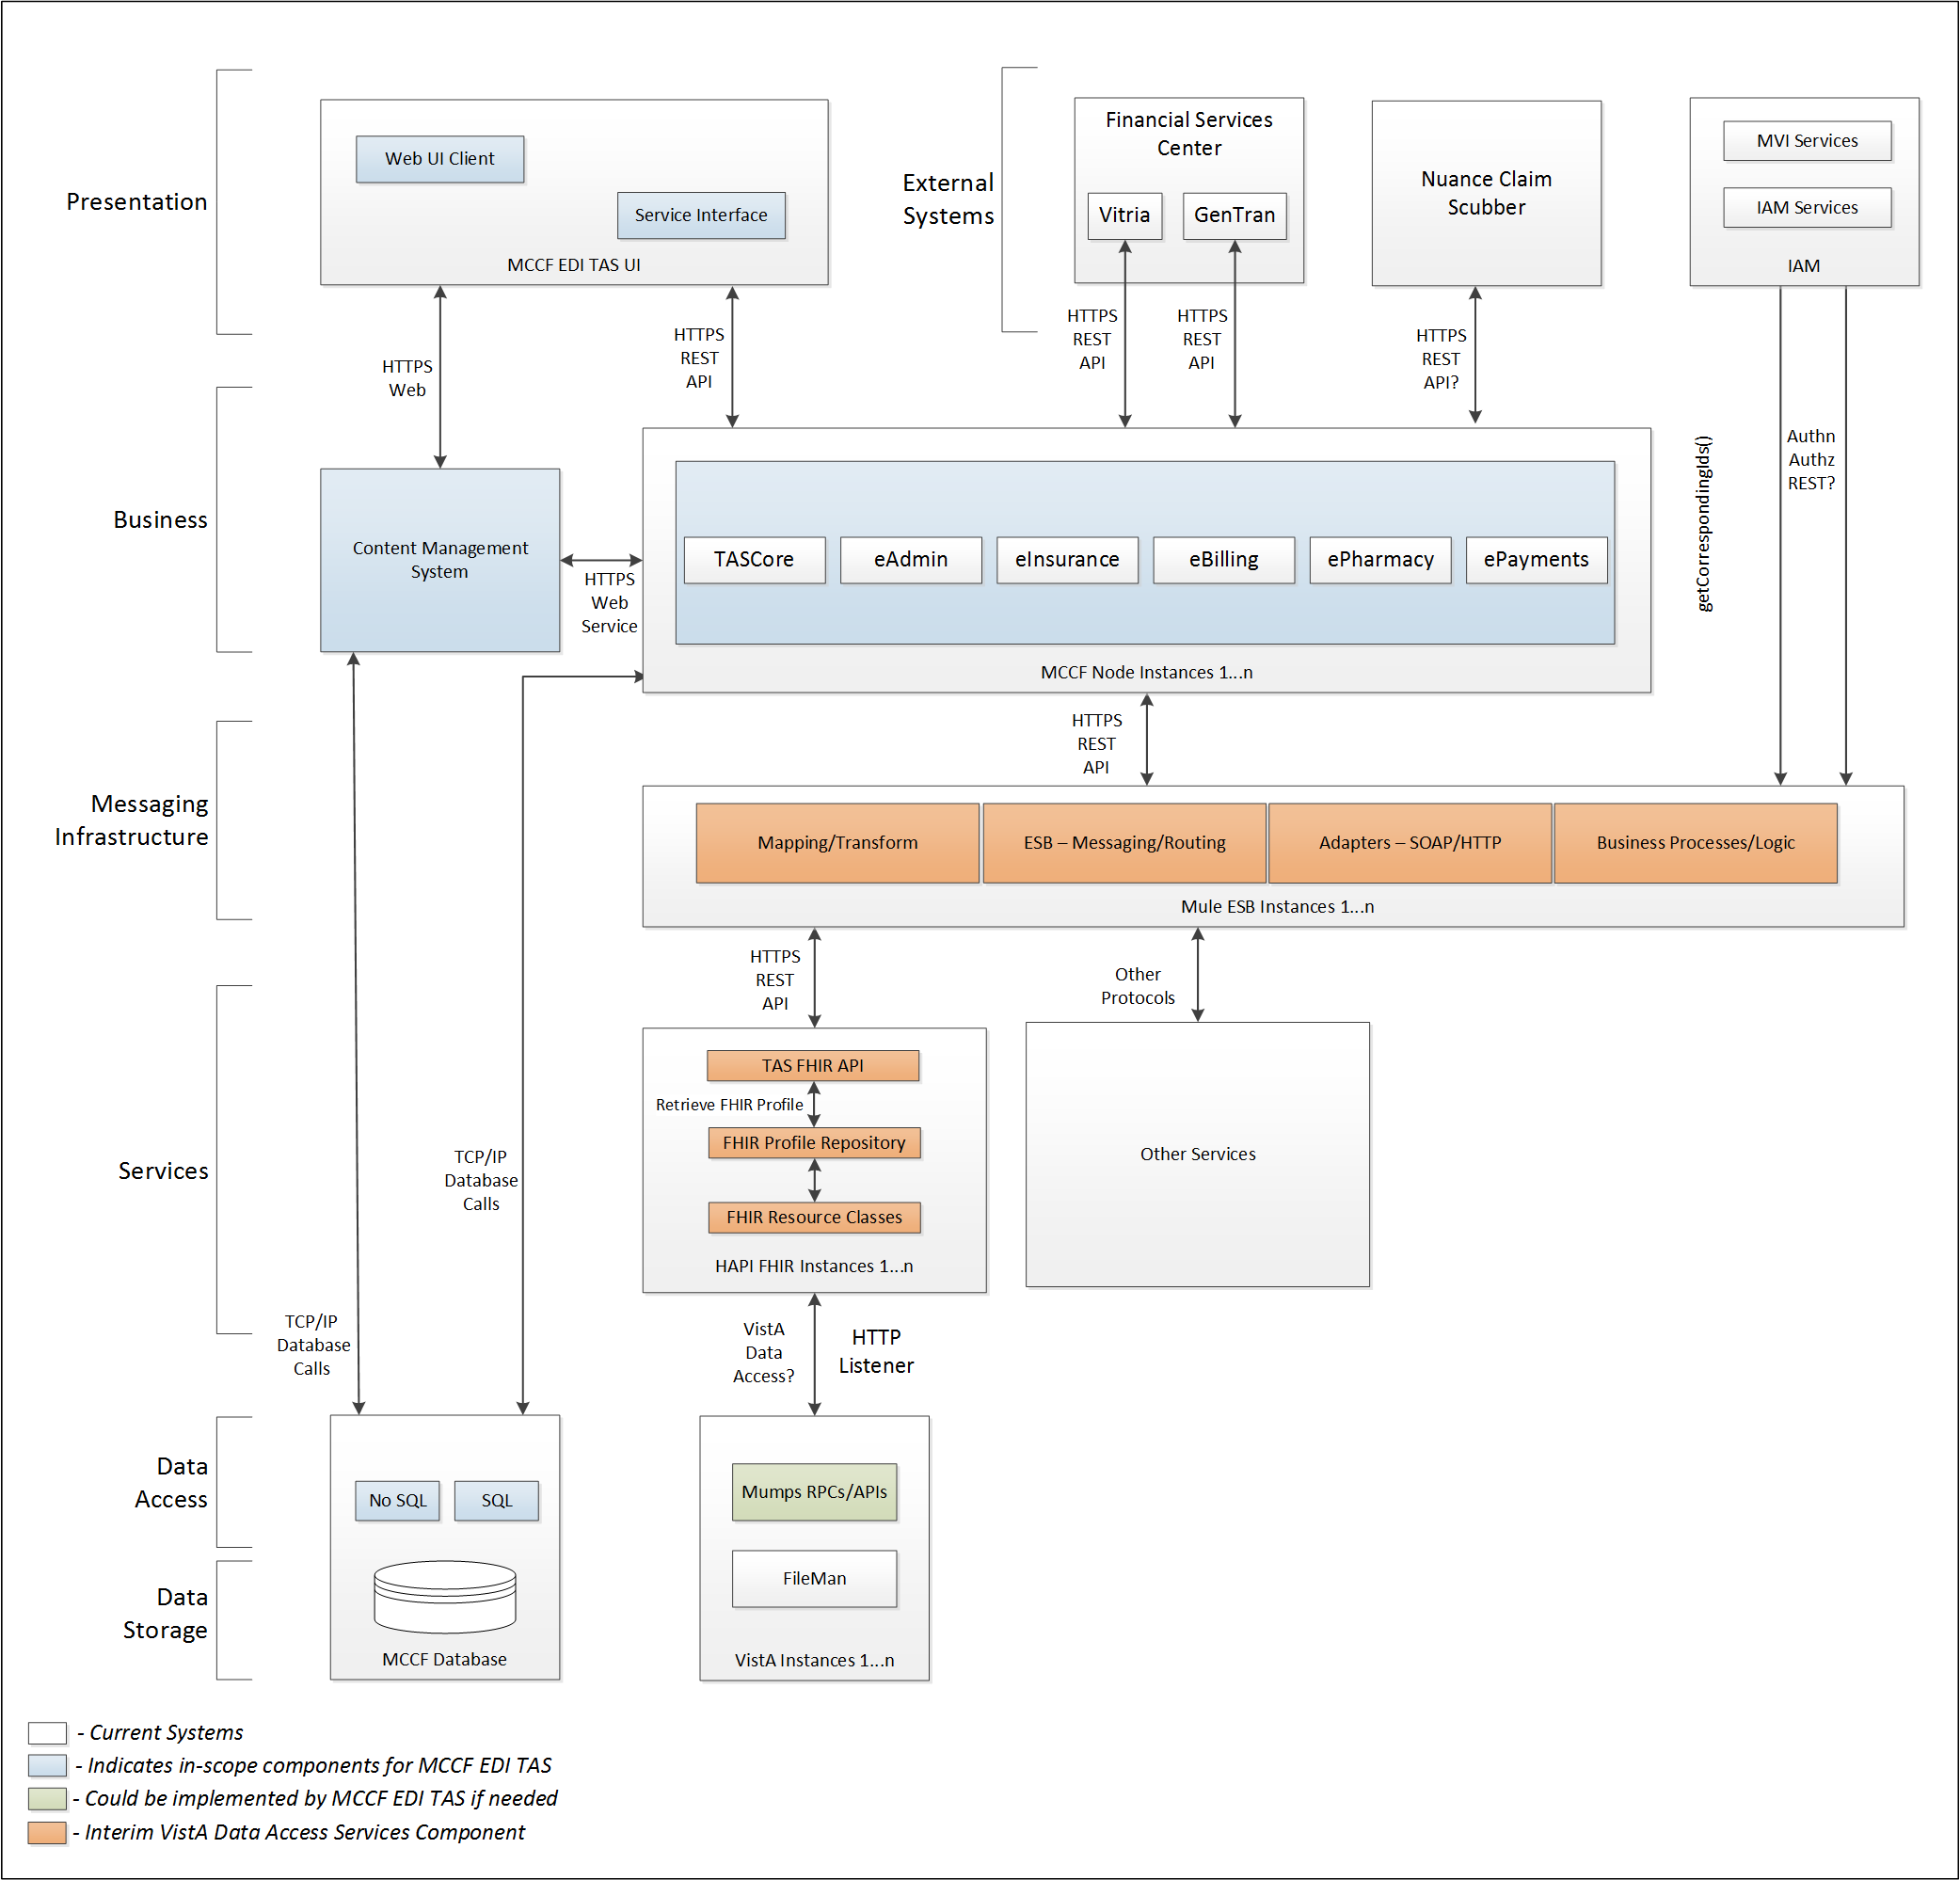

To be solution

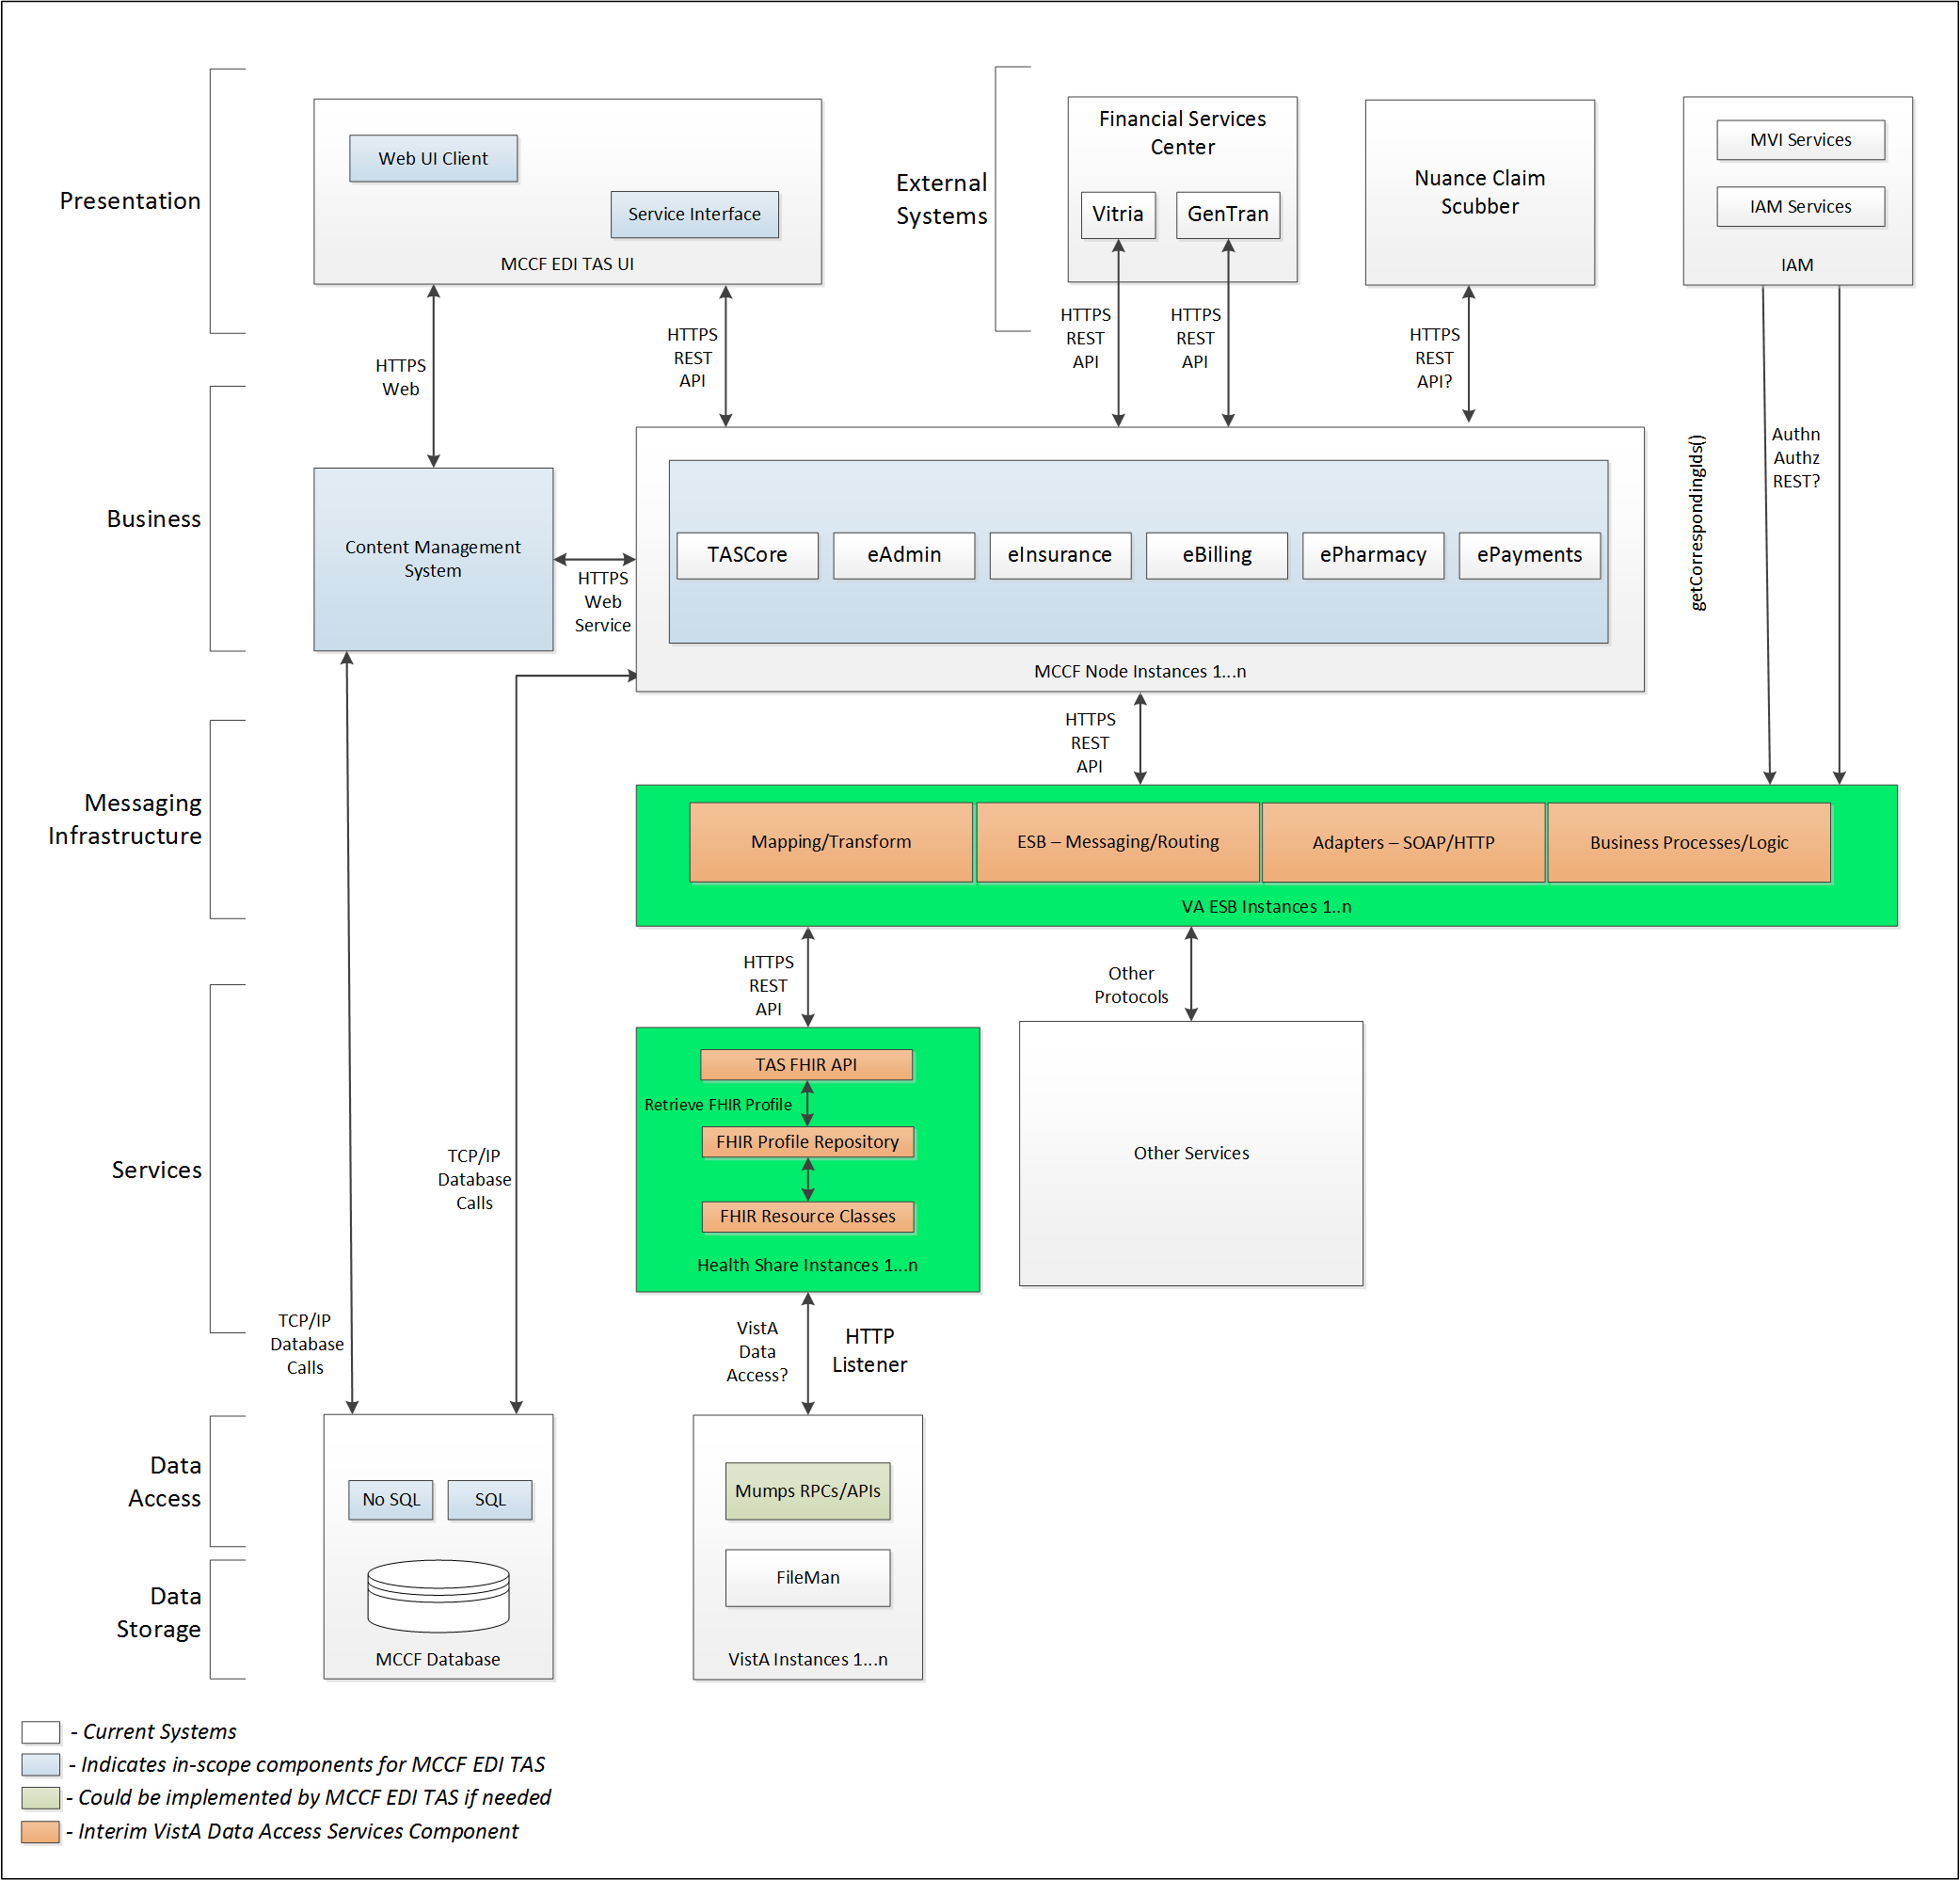

## Interface Overview

Exchanging messages between MCCF EDI TAS eBilling and FSC can be done in real time or as queued messaging.

### Connectivity between the systems

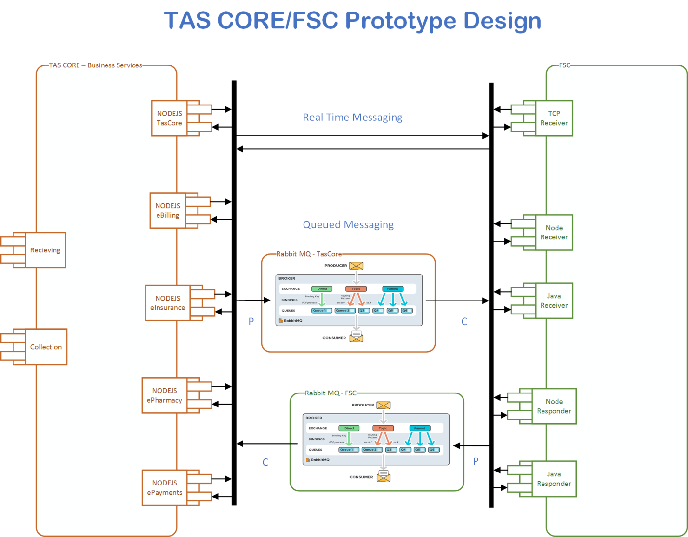

## Operations

Tbd

### Data Extraction

Data being sent to FSC will be extracted from the VistA databases using a FHIR server.

### Data Transformation

Tbd

### Sending/Receiving

MCCF EDI TAS sends FHIR Bundles to FSC that FSC translates to 278x217 request messages and receives FHIR Bundles representing 278x217 response messages from FSC.

MCCF EDI TAS sends FHIR Bundles to FSC that FSC translates to 278x215 inquiry messages and receives FHIR Bundles representing 278x215 responses from FSC.

## Data Transfer

Data is transferred between the FSC and the TASCore Application Stack.

## Transaction Types

MCCF EDI TAS transmits FHIR bundles consisting of different FHIR resources needed to construct a 278x217 request and 278x215 inquiry type messages.

FSC receives 278x217 response and 278x215 response types from payers and transmits that data in FHIR resources inside FHIR bundles to MCCF EDI TAS.

## Data Exchanges

MCCF EDI TAS sends a 278 Request FHIR bundle (for 278x217 requests and 278x215 inquiries) to FSC and receives a 278 Response FHIR bundle (for 278x217 and 278x215 responses) from FSC. Refer to Section Appendix A.

### FHIR Based Resources

The following FHIR resources are needed to assemble a 278 Request FHIR bundle

* Appointment
* Basic
* BodySite
* CarePlan
* ChargeItem
* Claim
* ClaimResponse
* ClinicalImpression
* Communication
* CommunicationRequest
* Condition
* Consent
* Coverage
* DataElement
* Device
* DiagnosticReport
* Encounter
* EpisodeOfCare
* HealthcareService
* Location
* MedicationAdministration
* MedicationDispense
* MedicationRequest
* MessageHeader
* Observation
* Organization
* Patient
* Practitioner
* PractitionerRole
* Procedure
* ProcessRequest
* RelatedPerson
* RiskAssessment
* ValueSet

The following FHIR resources are needed to assemble a 278 Response FHIR bundle

* Basic
* BodySite
* CarePlan
* ChargeItem
* Claim
* ClaimResponse
* Communication
* CommunicationRequest
* Condition
* Coverage
* Device
* DiagnosticReport
* Encounter
* EpisodeOfCare
* HealthcareService
* Location
* MedicationAdministration
* MedicationDispense
* MessageHeader
* Observation
* OperationOutcome
* Organization
* Patient
* Practitioner
* PractitionerRole
* Procedure
* ProcessRequest
* RelatedPerson
* RiskAssessment

### JSON Format

Messages are formatted using the JSON format and implement a Bundle FHIR Resource.

Refer to <https://www.hl7.org/fhir/json.html> for JSON representation of FHIR Resources.

#### 278 Request FHIR bundle

A bundle implementing a 278 request sent to FSC will have the following structure:

See Appendix A.

#### 278 Response FHIR bundle

A bundle implementing a 278 request sent to FSC will have the following structure:

See Appendix A.

### Bundle Definition

A Bundle is a top level container in FHIR that contains all the FHIR resources desired for a transaction between MCCF EDI TAS and FSC.

A Bundle is a container for resources, enabling one to group and transmit resources altogether at once. Resources such as Claim, Patient, etc. will be transmitted inside multiple entries (see entry list inside Bundle) as a resource type.

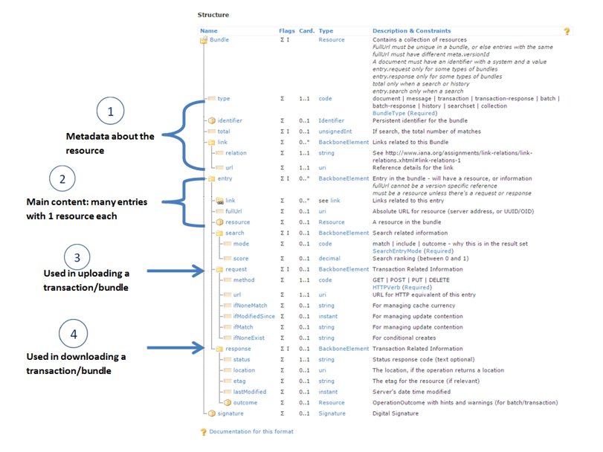

Figure 1 - Source https://fhir-drills.github.io/bundle.html

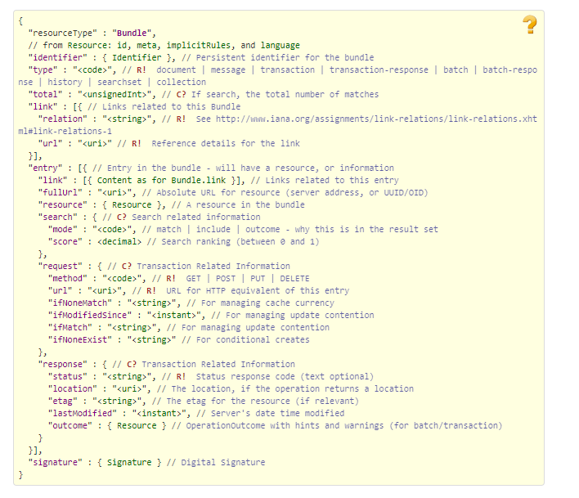

Figure 2 - Source <https://www.hl7.org/fhir/bundle.html>

## Communications Methods

### Ports and Protocols

#### HTTP(S)

Can be used for real time communication.

#### AMQP

AMQP offers reliable messaging via queues.

### ESB Configuration(s)

Tbd

### System Configuration

Tbd

## Performance Requirements

System Design Document (SDD); Medical Care Collection Fund (MCCF) - Electronic Data Interchange Transaction Application Suite (EDI TAS).

## Security

System Design Document (SDD); Medical Care Collection Fund (MCCF) - Electronic Data Interchange Transaction Application Suite (EDI TAS).

### Is within the VA firewall

Tbd

## Testing Requirements

System Design Document (SDD); Medical Care Collection Fund (MCCF) - Electronic Data Interchange Transaction Application Suite (EDI TAS).

### Comparison of Data

Tbd

### Completeness

Tbd

## Policies and Constraints

Tbd

### HIPAA Compliance

FSC receives transactions and then translates them into standard ASC X12N/005010 278 Health Care Eligibility Benefits Inquiry, validates whether or not the data complies with HIPAA standards and then forwards the claim data to the VA Healthcare Clearing House (HCCH).

# Appendix A

## Data Elements

## Bundle

Repeating fields within a segment need context definition so they can be differentiated within a segment.

Also, repeating fields across multiple segments need to be differentiated. Following steps have been used to assign context to fields.

1. Identify the segment where the resource is located (Bundle.entry.extension.url="segment" and Bundle.entry.extension.valueString="278-EVN") [MessageType-Segment]

2. Where elements repeat within a segment use extension.valueString to identify field (Basic.extension.url="sequence" and Basic.extension.valueString="278-MSH-16" or Location.identifier.extension.url="sequence" and Location.identifier.extension.valueString="278-MSH-3") [MessageType-Segment-Field]

3. Repeating segments will include an incrementing id (MSA1, MSA2, ...)

Following JSON file describes the 278 response. It is not complete and will be completed at a later time.



## Resource Sections 1..N

### 278 Request FHIR Bundle Resources

#### Appointment

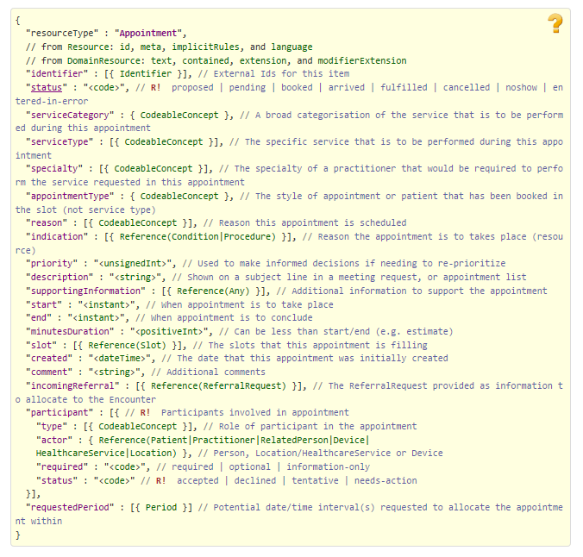

Figure 3 - https://www.hl7.org/fhir/appointment.html

#### Basic

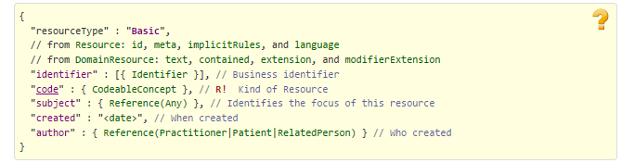

Figure 4 - https://www.hl7.org/fhir/basic.html

#### BodySite

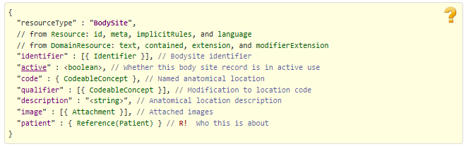

Figure 5 - https://www.hl7.org/fhir/bodysite.html

#### CarePlan

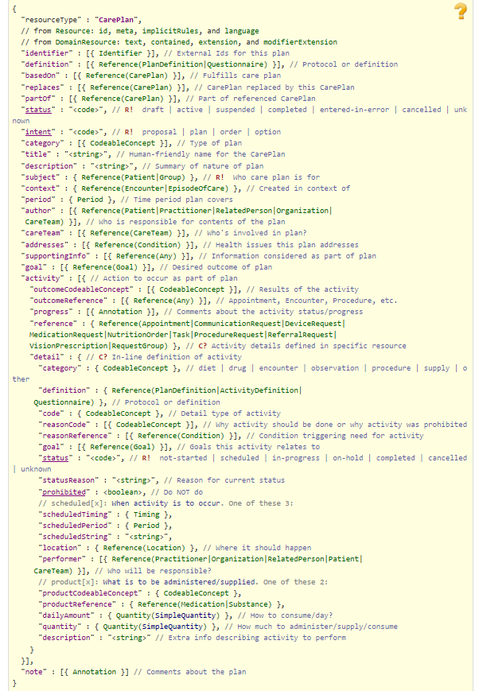

Figure 6 - https://www.hl7.org/fhir/careplan.html

#### ChargeItem

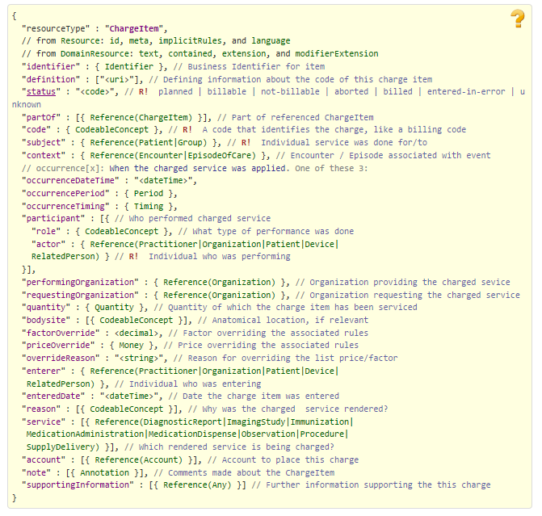

Figure 7 - https://www.hl7.org/fhir/chargeitem.html

#### Claim

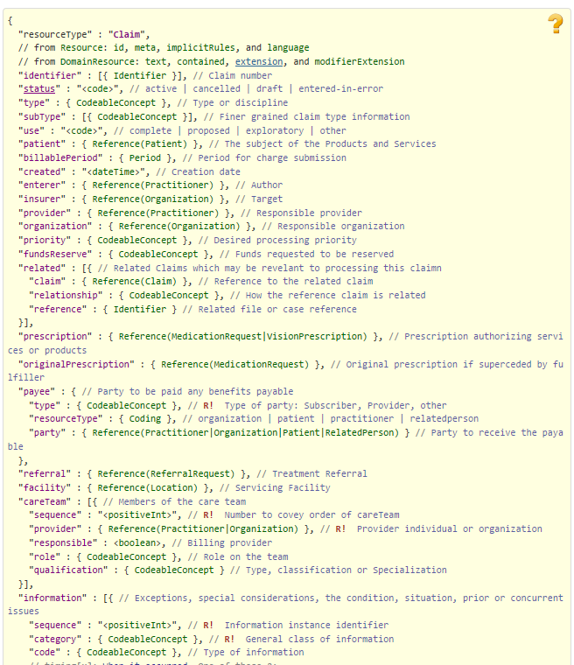

Figure 8 - https://www.hl7.org/fhir/claim.html Part 1

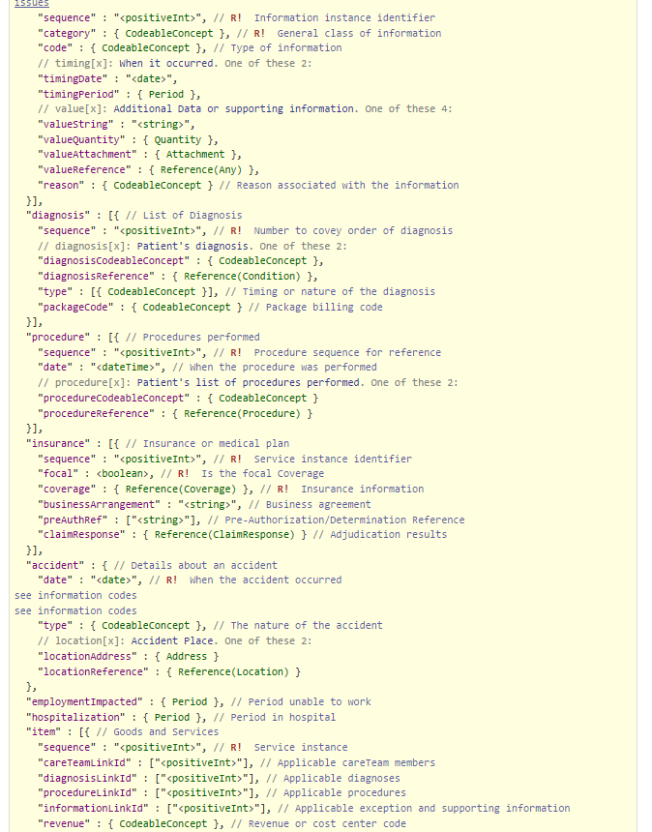

Figure 9 - https://www.hl7.org/fhir/claim.html Part 2

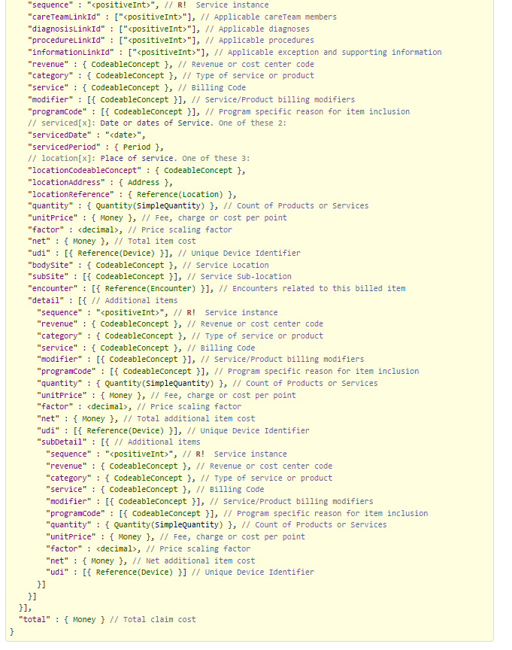

Figure 10 - https://www.hl7.org/fhir/claim.html Part 3

#### ClaimResponse

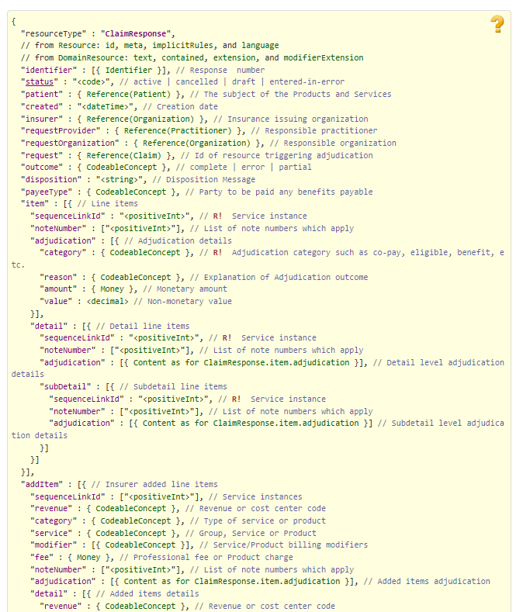

Figure 11 - https://www.hl7.org/fhir/claimresponse.html Part 1

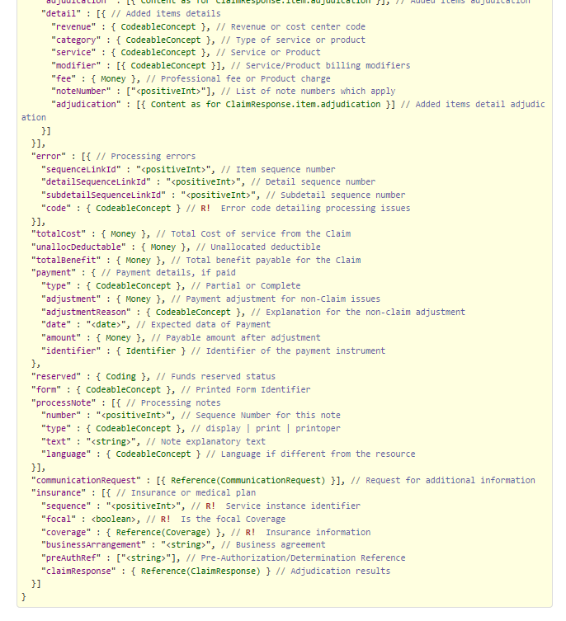

Figure 12 - https://www.hl7.org/fhir/claimresponse.html Part 2

#### ClinicalImpression

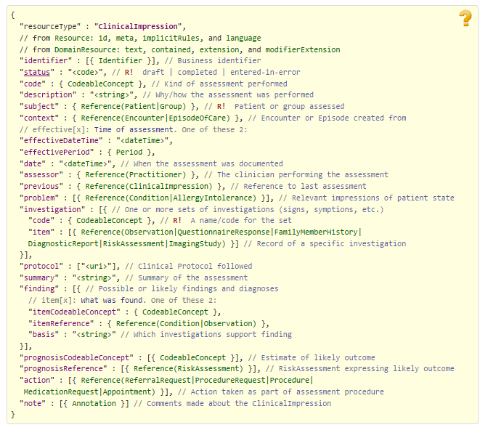

Figure 13 - https://www.hl7.org/fhir/clinicalimpression.html

#### Communication

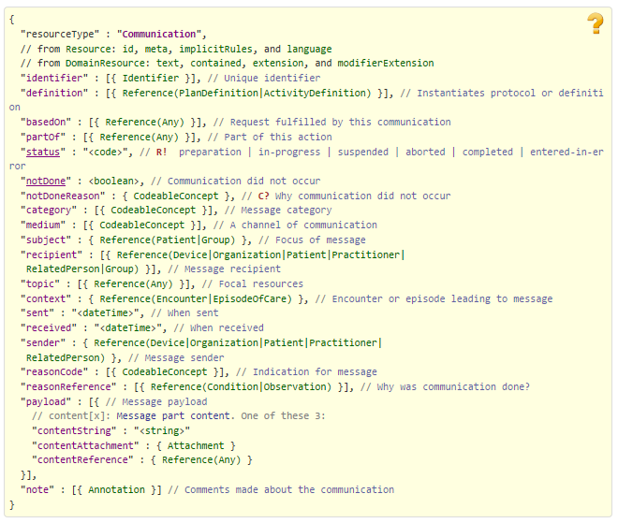

Figure 14 - https://www.hl7.org/fhir/communication.html

#### CommunicationRequest

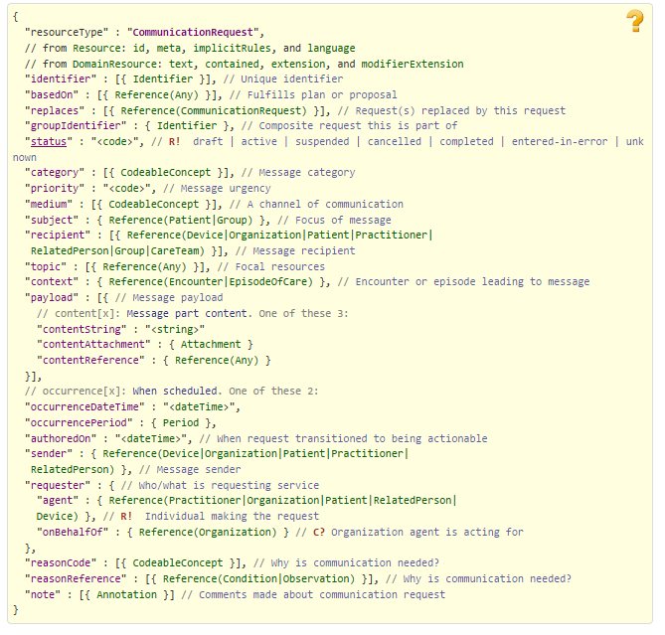

Figure 15 - https://www.hl7.org/fhir/communicationrequest.html

#### Condition

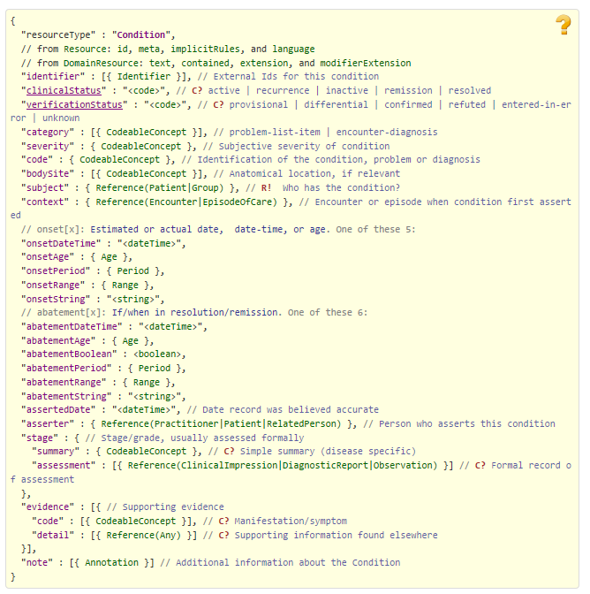

Figure 16 - https://www.hl7.org/fhir/condition.html

#### Consent

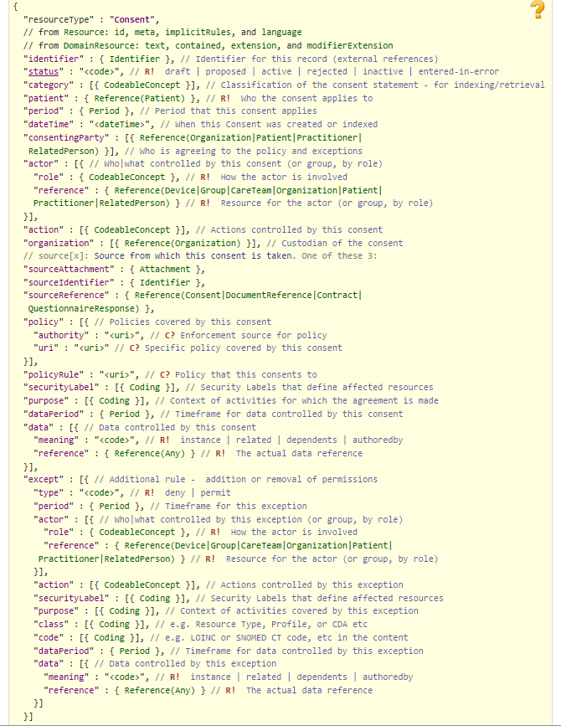

Figure 17 - https://www.hl7.org/fhir/consent.html

#### Coverage

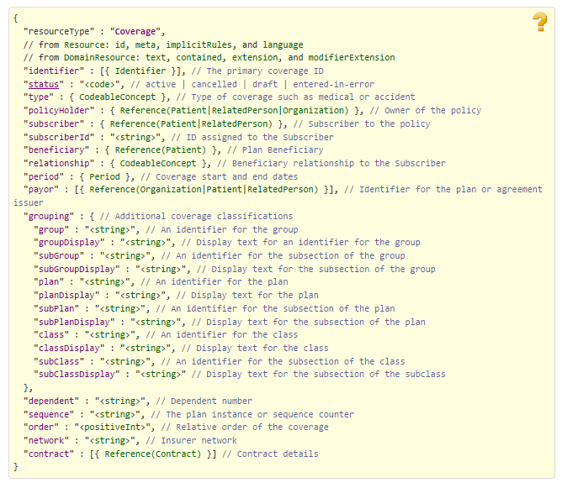

Figure 18 - https://www.hl7.org/fhir/coverage.html

#### DataElement

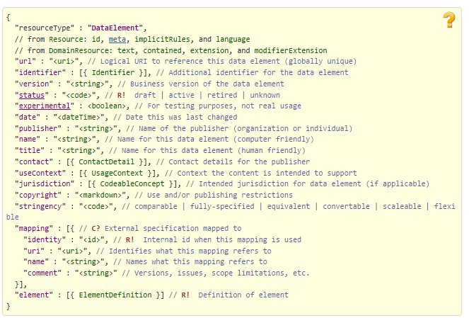

Figure 19 - https://www.hl7.org/fhir/dataelement.html

#### Device

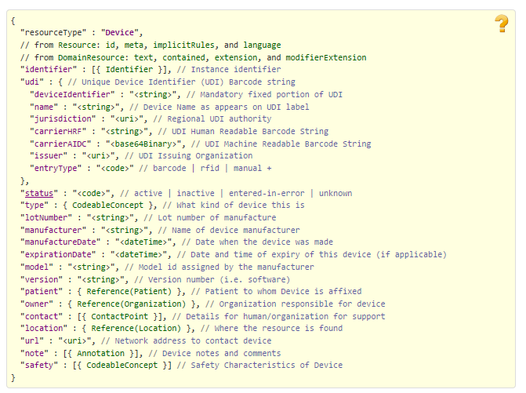

Figure 20 - https://www.hl7.org/fhir/device.html

#### DiagnosticReport

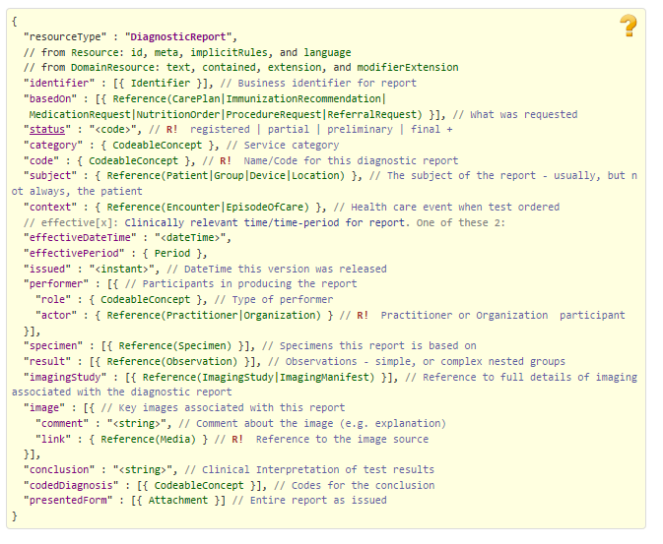

Figure 21 - https://www.hl7.org/fhir/diagnosticreport.html

#### Encounter

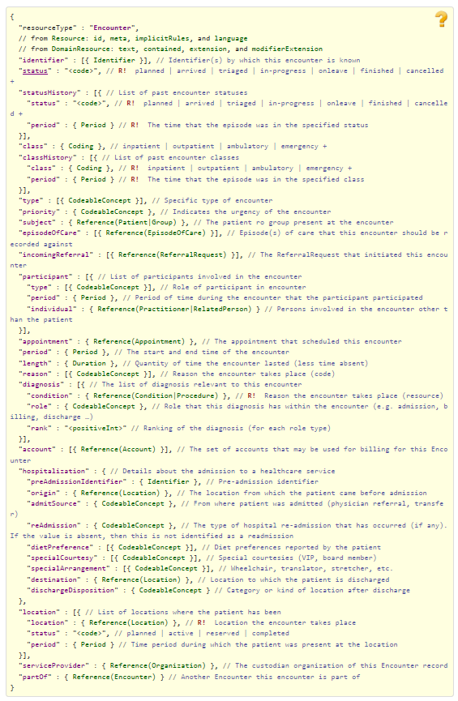

Figure 22 - https://www.hl7.org/fhir/encounter.html

#### EpisodeOfCare

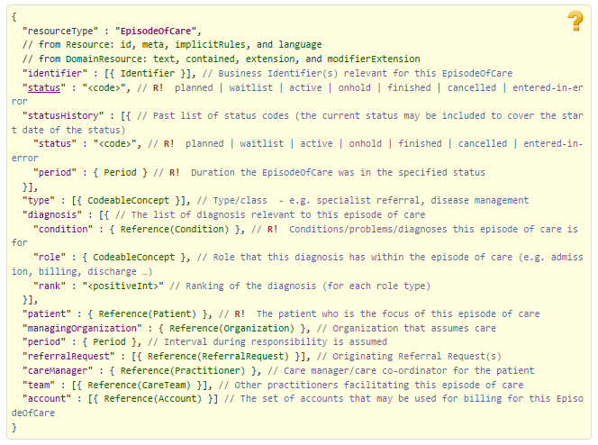

Figure 23 - https://www.hl7.org/fhir/episodeofcare.html

#### HealthcareService

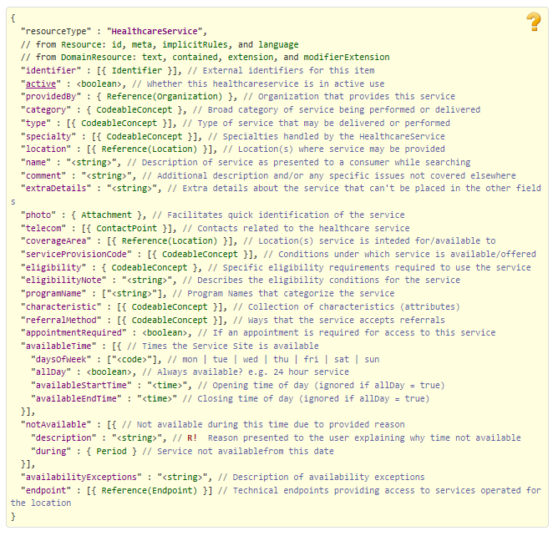

Figure 24 - https://www.hl7.org/fhir/healthcareservice.html

#### Location

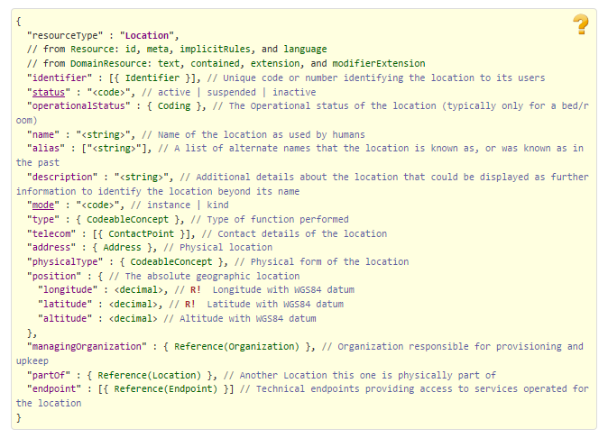

Figure 25 - https://www.hl7.org/fhir/location.html

#### MedicationAdministration

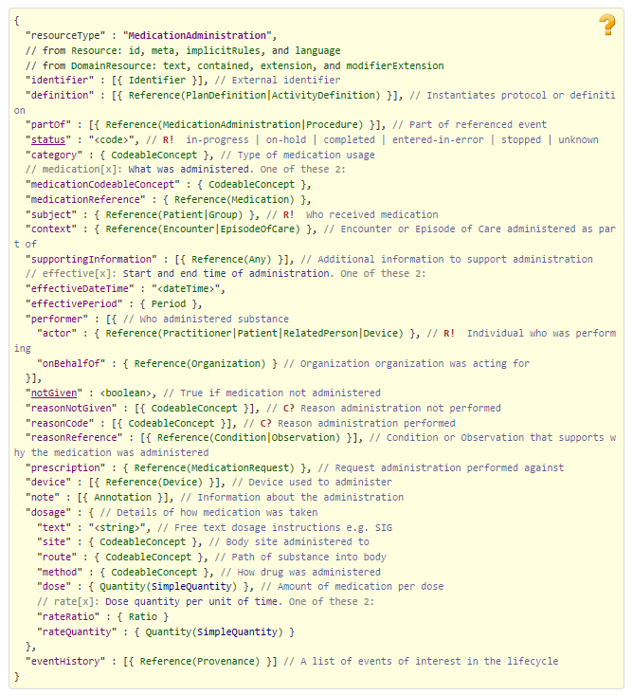

Figure 26 - https://www.hl7.org/fhir/medicationadministration.html

#### MedicationDispense

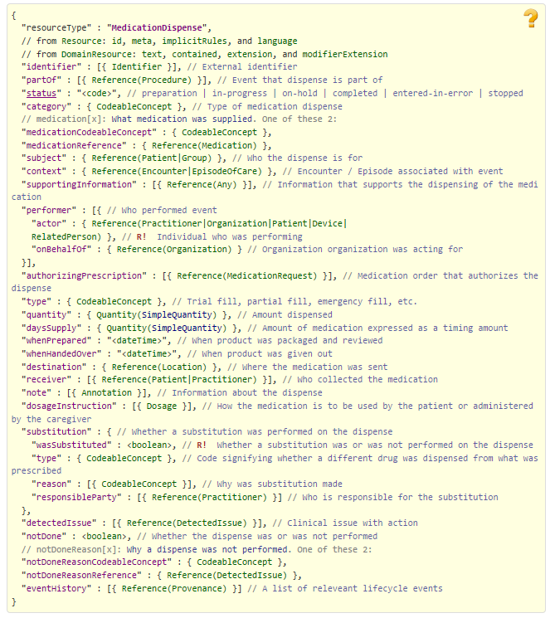

Figure 27 - https://www.hl7.org/fhir/medicationdispense.html

#### MedicationRequest

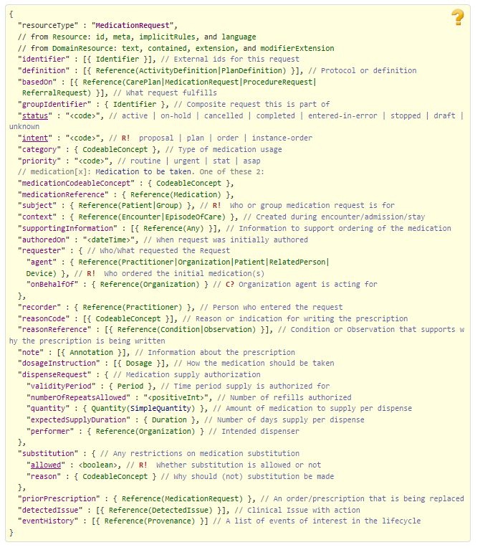

Figure 28 - https://www.hl7.org/fhir/medicationrequest.html

#### MessageHeader

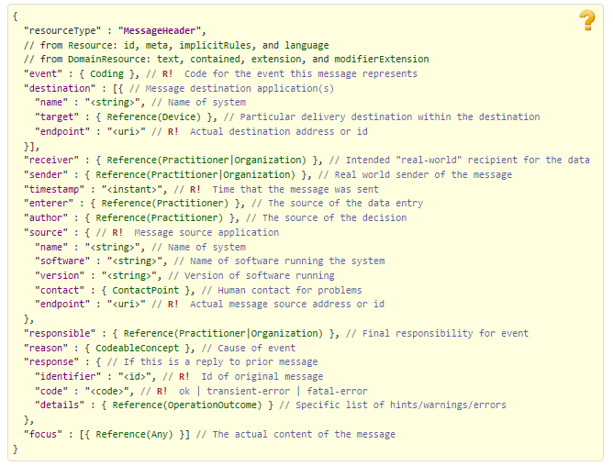

Figure 29 - https://www.hl7.org/fhir/messageheader.html

#### Observation

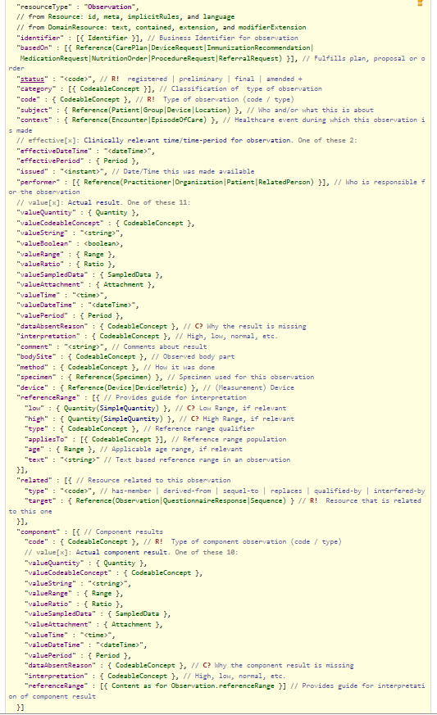

Figure 30 - https://www.hl7.org/fhir/observation.html

#### Organization

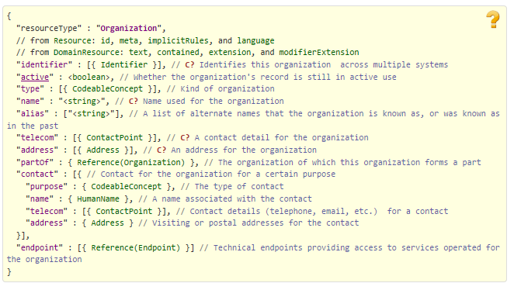

Figure 31 - https://www.hl7.org/fhir/organization.html

#### Patient

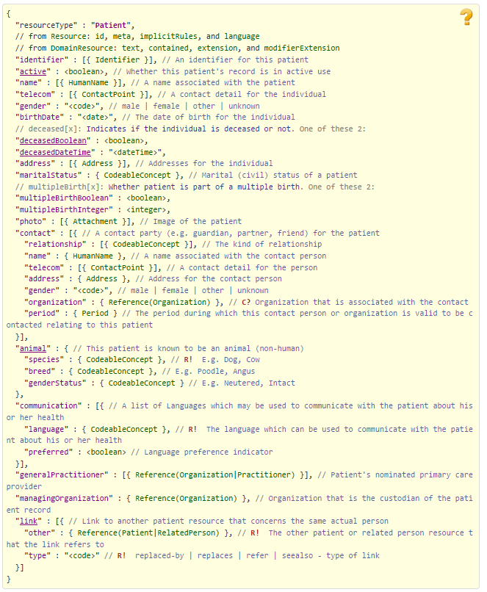

Figure 32 - https://www.hl7.org/fhir/patient.html

#### Practitioner

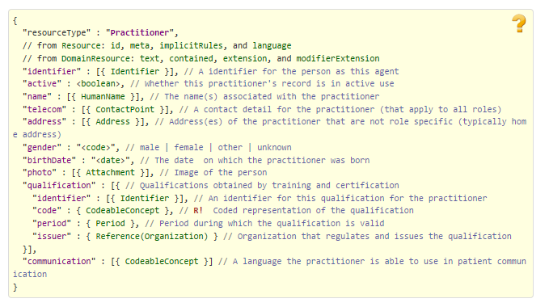

Figure 33 - https://www.hl7.org/fhir/practitioner.html

#### PractitionerRole

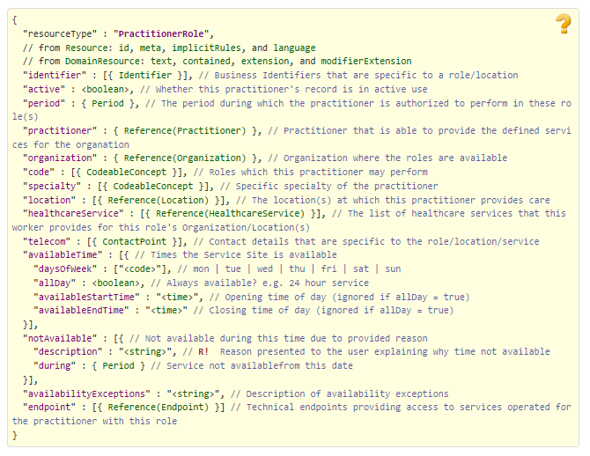

Figure 34 - https://www.hl7.org/fhir/practitionerrole.html

#### Procedure

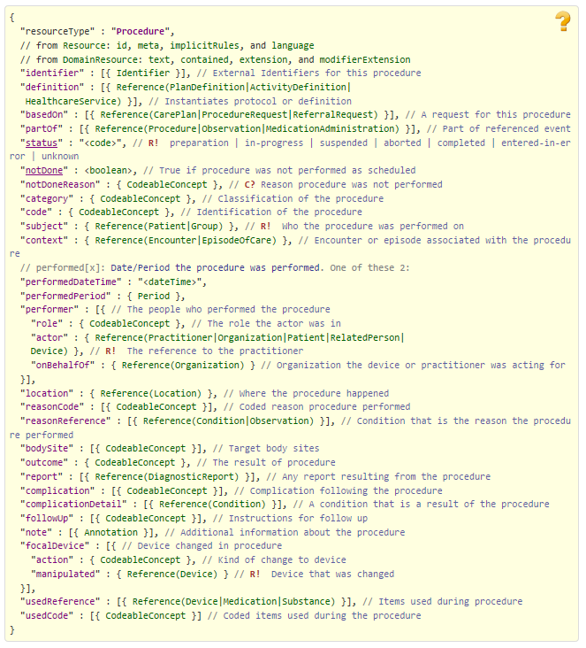

Figure 35 - https://www.hl7.org/fhir/procedure.html

#### ProcessRequest

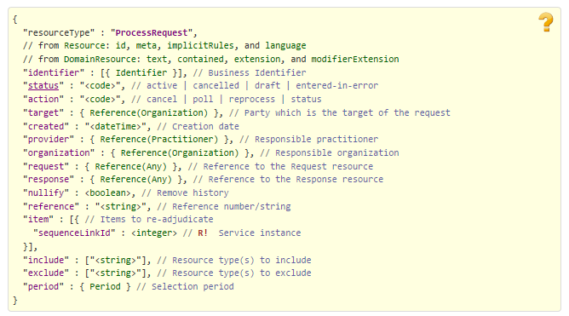

Figure 36 - https://www.hl7.org/fhir/processrequest.html

#### RelatedPerson

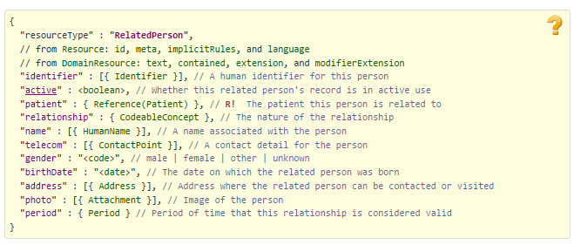

Figure 37 - https://www.hl7.org/fhir/relatedperson.html

#### RiskAssessment

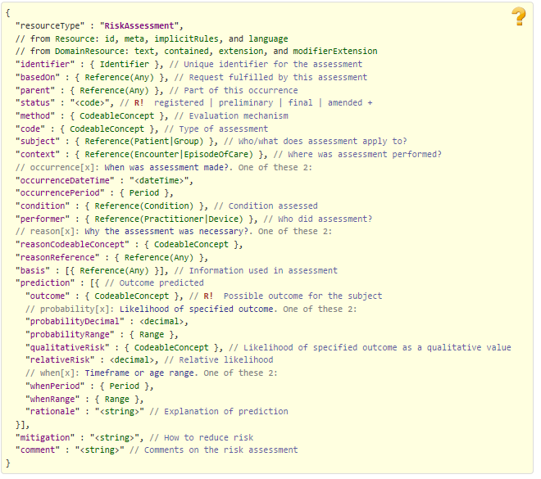

Figure 38 - https://www.hl7.org/fhir/riskassessment.html

#### ValueSet

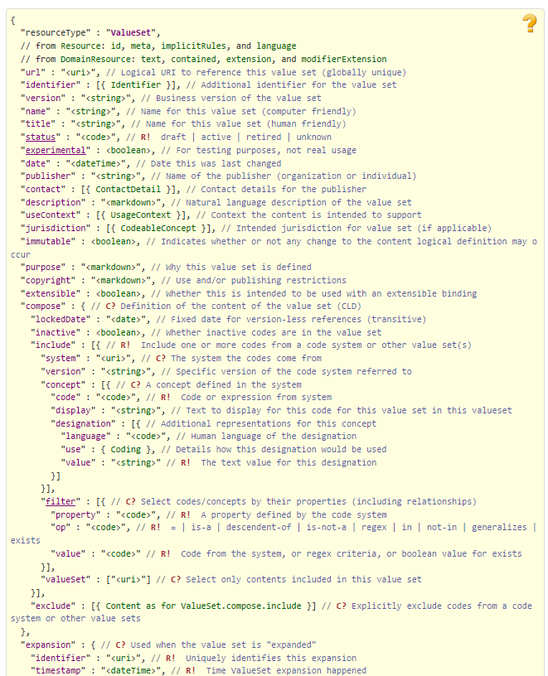

Figure 39 - https://www.hl7.org/fhir/valueset.html Part 1

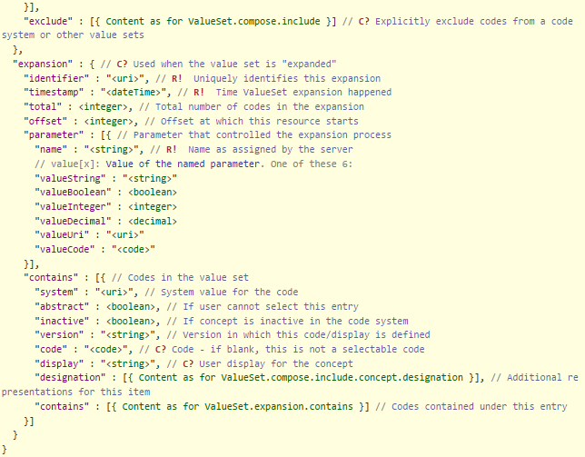

Figure 40 - https://www.hl7.org/fhir/valueset.html Part 2

### 278 Response FHIR Bundle Resources

#### Basic

See 278 Request FHIR Bundle Resources section.

#### BodySite

See 278 Request FHIR Bundle Resources section.

#### CarePlan

See 278 Request FHIR Bundle Resources section.

#### ChargeItem

See 278 Request FHIR Bundle Resources section.

#### Claim

See 278 Request FHIR Bundle Resources section.

#### ClaimResponse

See 278 Request FHIR Bundle Resources section.

#### Communication

See 278 Request FHIR Bundle Resources section.

#### CommunicationRequest

See 278 Request FHIR Bundle Resources section.

#### Condition

See 278 Request FHIR Bundle Resources section.

#### Coverage

See 278 Request FHIR Bundle Resources section.

#### Device

See 278 Request FHIR Bundle Resources section.

#### DiagnosticReport

See 278 Request FHIR Bundle Resources section.

#### Encounter

See 278 Request FHIR Bundle Resources section.

#### EpisodeOfCare

See 278 Request FHIR Bundle Resources section.

#### HealthcareService

See 278 Request FHIR Bundle Resources section.

#### Location

See 278 Request FHIR Bundle Resources section.

#### MedicationAdministration

See 278 Request FHIR Bundle Resources section.

#### MedicationDispense

See 278 Request FHIR Bundle Resources section.

#### MessageHeader

See 278 Request FHIR Bundle Resources section.

#### Observation

See 278 Request FHIR Bundle Resources section.

#### OperationOutcome

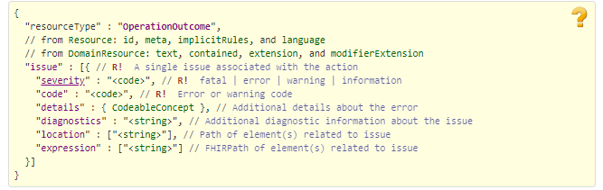

Figure 41 Source http://www.hl7.org/fhir/operationoutcome.html

#### Organization

See 278 Request FHIR Bundle Resources section.

#### Patient

See 278 Request FHIR Bundle Resources section.

#### Practitioner

See 278 Request FHIR Bundle Resources section.

#### PractitionerRole

See 278 Request FHIR Bundle Resources section.

#### Procedure

See 278 Request FHIR Bundle Resources section.

#### ProcessRequest

See 278 Request FHIR Bundle Resources section.

#### RelatedPerson

See 278 Request FHIR Bundle Resources section.

#### RiskAssessment

See 278 Request FHIR Bundle Resources section.

### Embedded following columns:

#### Element #

#### Max Length

#### FSC Transaction Location

* FSC Comments
* FHIR Resource
* TASCore Comments

# Appendix B - TASCore Mapping Rules

# Appendix C – TASCore Default Values

# Appendix D – FSC Mapping Rules

# Appendix E – FSC Default Values